I made two sets of models. Model 1 follows the functional form below

Model 2 follows the functional form below

lnMortality10 represents the natural log of mortality for the same cohort 10 years past; ex. For 25 year old males in 1960, lnMortality10 is equal to lnMortality for 15 year old males in 1950. For both models, age categories were broken up into the following categories: 5-9, 10-19, 20-29, 30-39, 40-49, 50-59, 60-69, 70-79, 80, of which the 10-19 age group was treated as the base. Year decades were defined as the 1940s, 50s, 60s, 70s, 80s, 90s, 00s, and 10s, of which the 1950s were treated as the base.

After these models were calculated, I made two sets of graphs

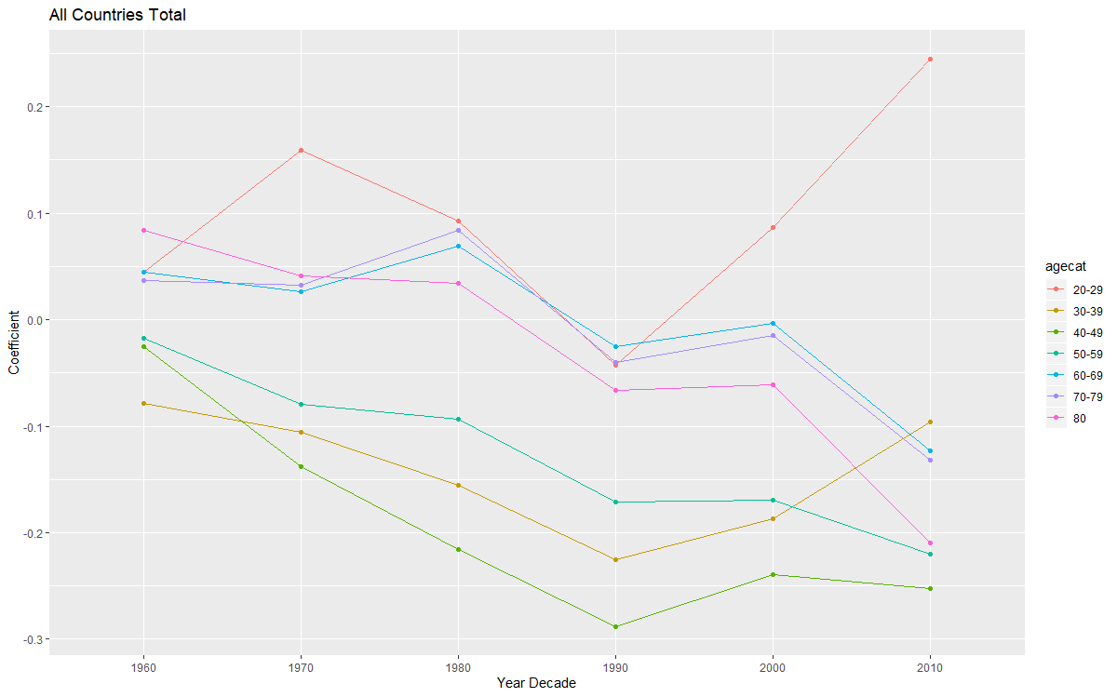

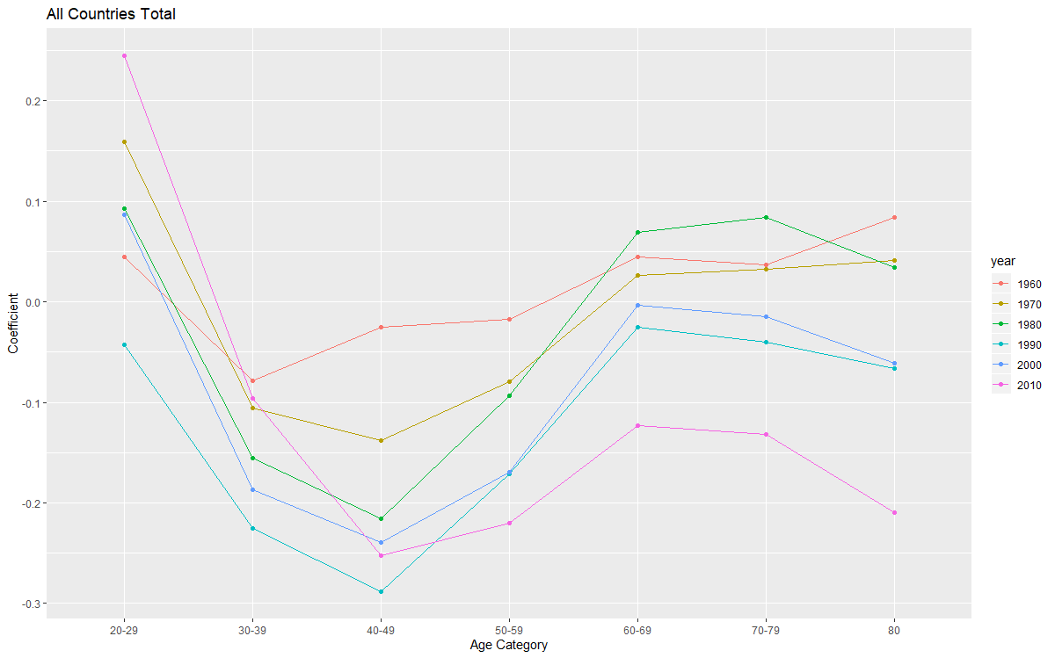

**Graph Appendix:**

**Section 1: Model 1 Graphs**

*Part Ia: Just The Triple Interactions, X Axis is Year Decade and Series are Age Categories*



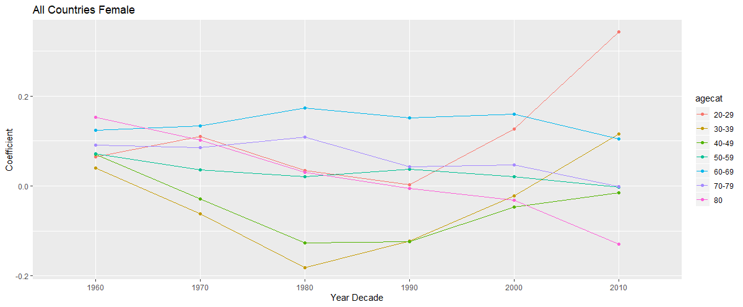

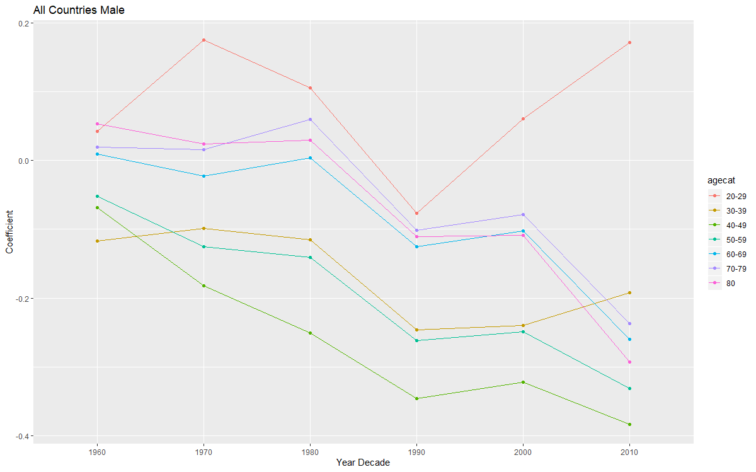

*Part Ib: Just The Triple Interactions, X Axis is Age Categories and Series Are YearDecade*



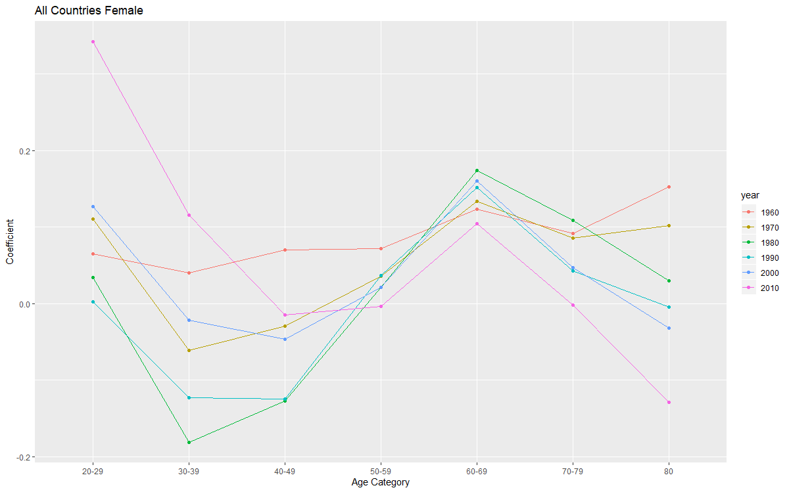

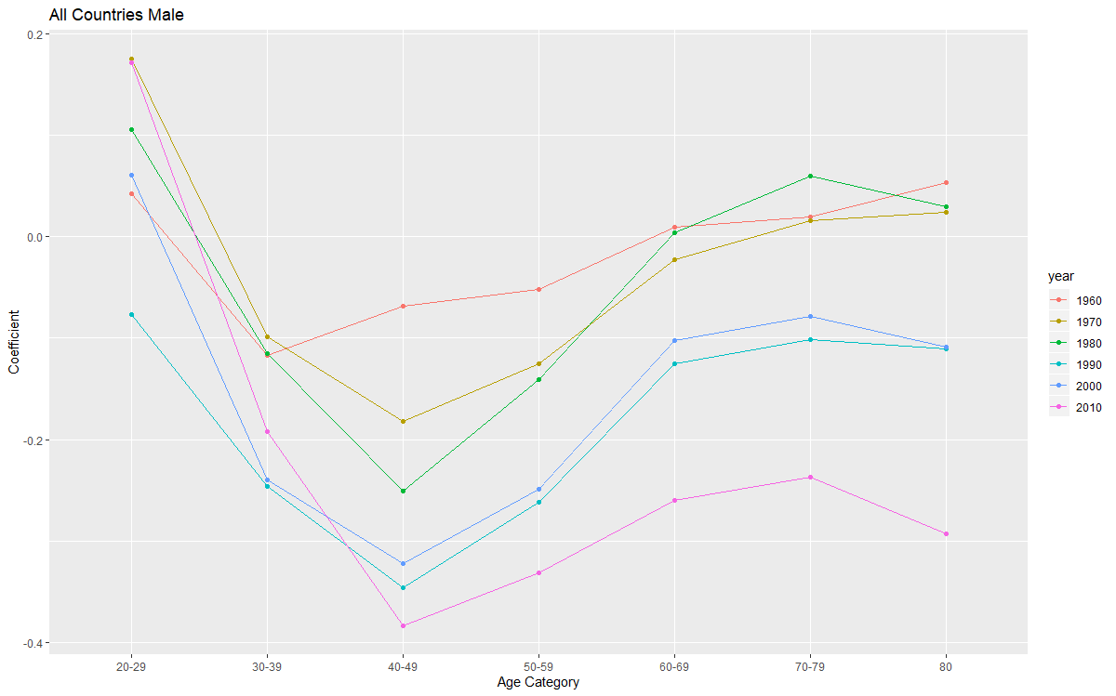

*Part IIa: Triple Coefficients Summed with Double Interaction Terms and US Term, X is Year Decade and Series are Age Categories*

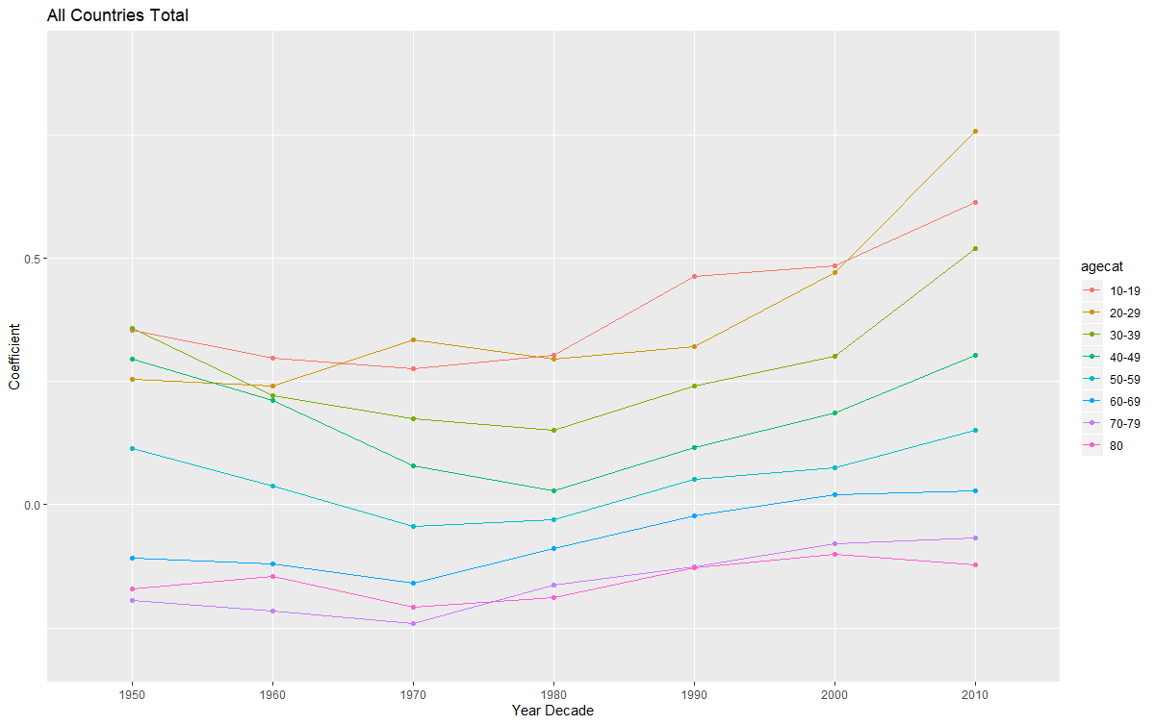

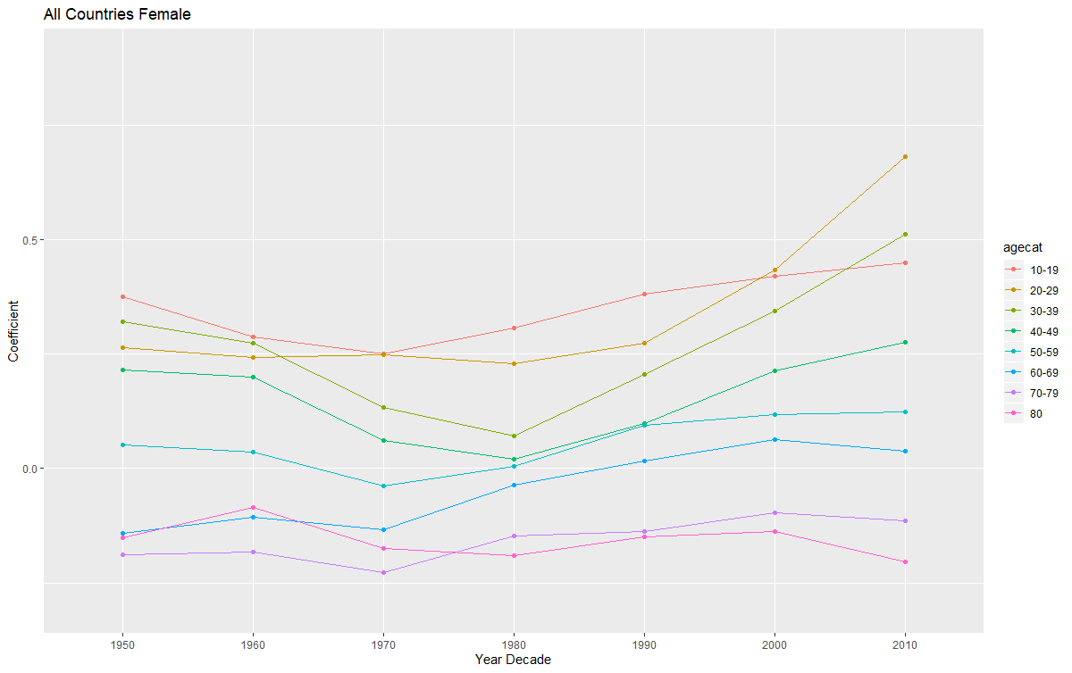

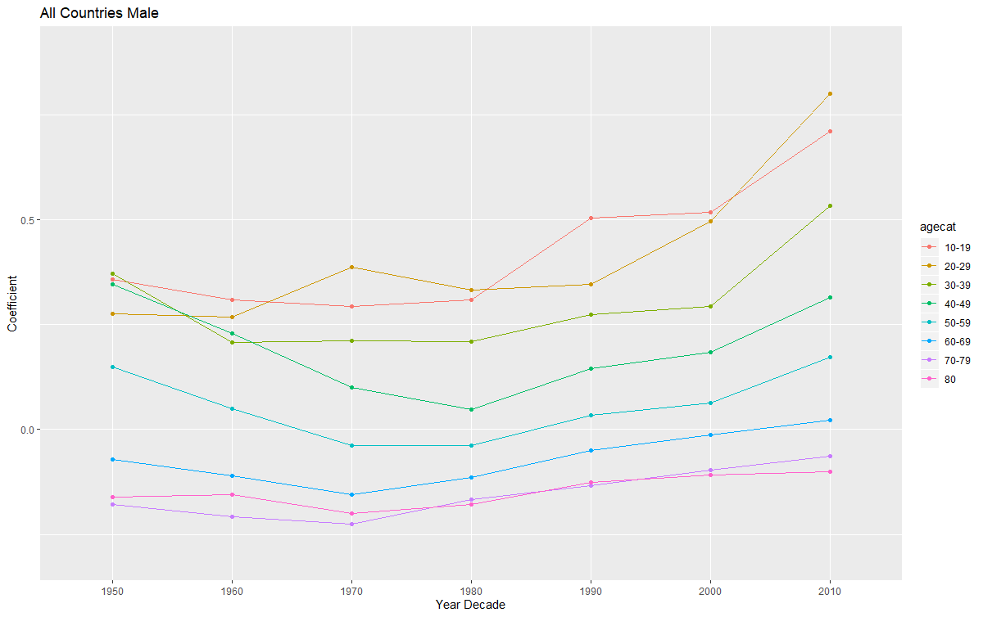

*Part IIb: Triple Interaction Coefficients Summed With Double Interaction Terms and US Coefficient, X Axis is Age Categories, Series are Year Decades*

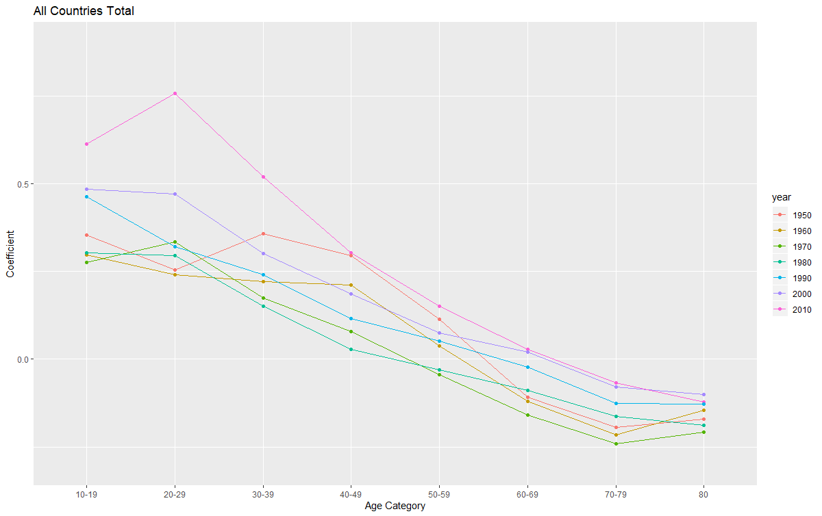

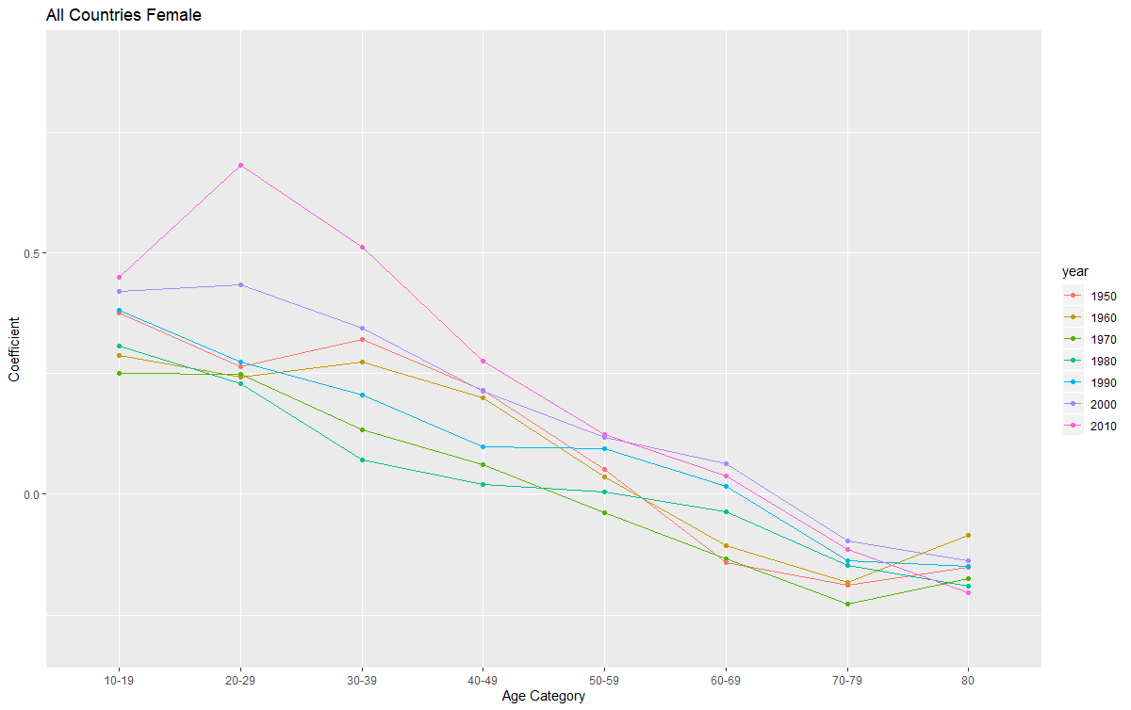

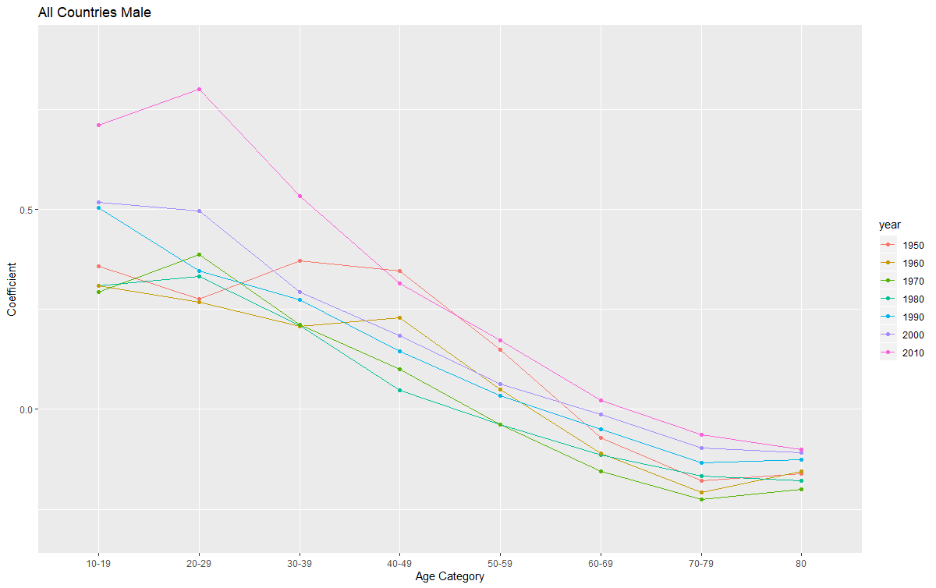

**Section 2: Model 2 Graphs**